My
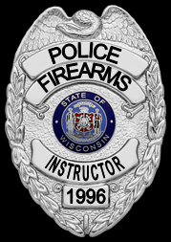
Personal
Defense Training, LLC.
MPD Training, LLC, will be providing the following training:
Concealed Carry Firearms Safety Class
Friday, October 18th, 2019 from 12:00 PM to 4:00 PM.
at the GMAR Office, 12300 W. Center St., Milwaukee, WI 53222 $50/person
Future training dates will be made available monthly.
As a WI Department of Justice (DOJ) certified firearms instructor, I have been teaching my police officers how to shoot safely, accurately, and tactically since 1996. My certification qualifies me to teach the DOJ Concealed Carry curriculum to private citizens. This class satisfies the training requirements necessary to obtain a concealed carry permit in the State of Wisconsin. This is a curriculum that you need to understand if you wish to undertake the responsibility of carrying a concealed weapon, or keeping one in the home or business for the purpose of self-defense. This is a foundation course so no previous experience is necessary and you will not need a personally owned handgun.
Please call MPD training at: 262-227-1846, or e-mail: steve@mpdconcealedcarry.com to reserve a seat or to inquire about future training dates. Custom classes for your group at your location are also available. Space is limited since I want to keep class sizes small to provide a more personalized, quality learning experience. Visit us at www.mpdconcealedcarry.com
Steve Bzdusek, owner/lead instructor

